PHONE TREE – Sample One

In the event of a loved one’s passing, communication with others is vital. A phone tree provides an organized way to contact multiple people and institutions by sharing responsibilities in the call protocol. The sample diagram below can be used as a template.

Name Closest to Loved One:

Organizational Support Person
Emotional Contact Person who contacts
other family and friends.
Who contacts hospice, 911 & other institutions

Name: |  | Name:
 |  |  |  | Name: |  | Name:
Loved on closest  to the person who’s passed - takes care of notifying companies - bills. |  | Organizational support person  Takes care of obtaining a certificate of death, and other legal proceedings.
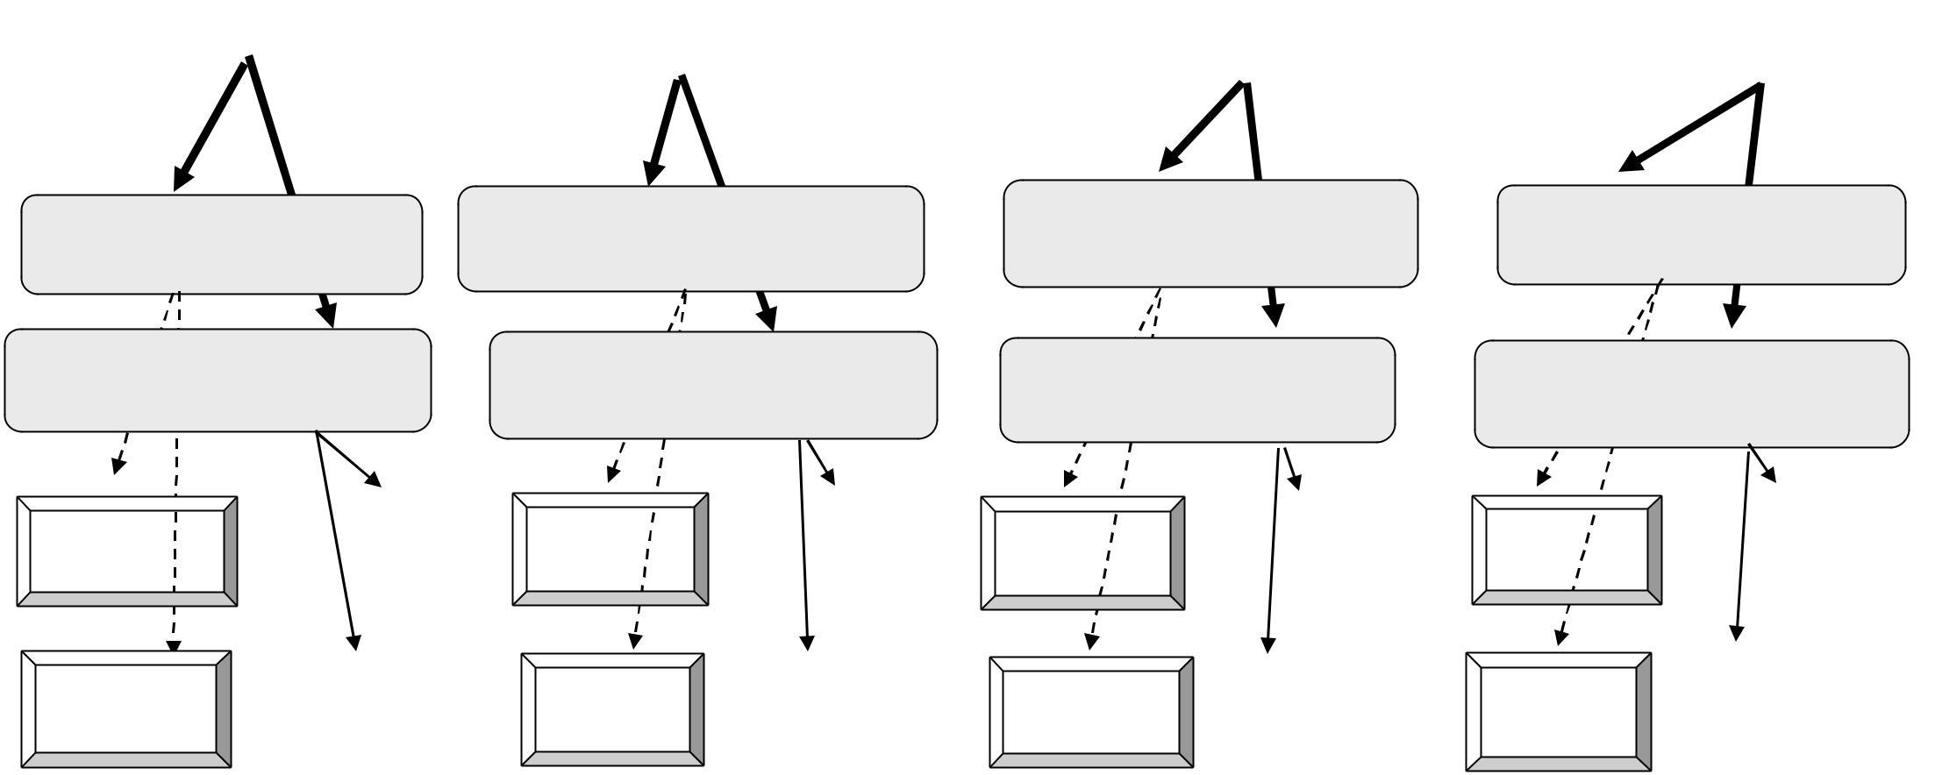

Name: | Name: | Name: | Name:

Name: | Name: | Name: | Name:

 |  |  |  |  |  | Name:
Name: |  | Name: |  | Name: |  |  |  | Name: |  | Name: |  | Name: |  | Name:

 |  |  |  |  |  |  | Name:
Name: | Name: | Name: | Name: | Name: | Name: | Name:

